Ankita Vashisht

**Using the RFM, analysis the retail_rfm.csv file attached and good explanation for results.**

Haven’t installed dplyr, bcz it was already installed.

So, I have installed library.

Set seed to stop iteration.

These are main codes and their explanations-

ntile: Divides data into n equally sized groups.

recency_days*-1: Multiplying by -1 ensures that more recent purchases (lower days) have higher scores.

**for (r in 1:groups) {**

**r_groups[[r]] <- filter(ankita, ankita$recency_score_seq == r)**

**r_groups[[r]]$frequency_score_seq <- ntile(r_groups[[r]]$number_of_orders, groups)**

Filtering**:** filter(ankita, ankita$recency_score_seq == r) filters the ankita dataset to get all customers who have a recency score of r.

Frequency Scoring**:** ntile(r_groups[[r]]$number_of_orders, groups) assigns frequency scores within each recency group.

**temp <- bind_rows(temp, rf_groups[[m]])**

**}**

**}**

bind_rows**:** Appends each subgroup (filtered by recency and frequency and scored by monetary to the temp dataframe.

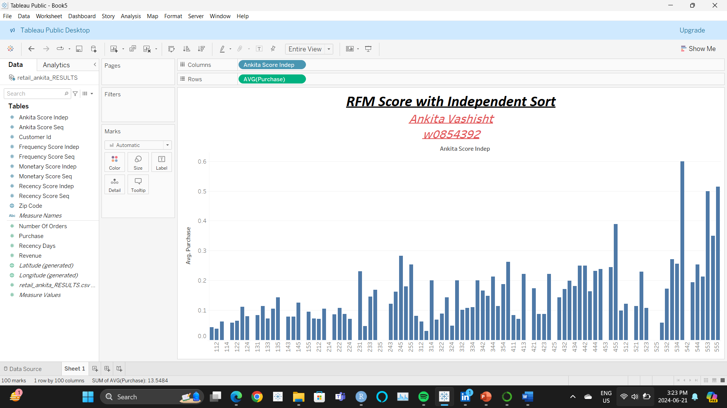

Purpose:

The Tableau visualization displays the average purchase amount for each RFM score, sorted independently.

Key Elements:-

1. Data Source:

- A CSV file named `retail_ankita_RESULTS.csv` containing RFM analysis results.

2. Fields Used:

- `Ankita Score Indep`: The RFM score based on independent sorting.

- `Purchase`: The purchase amount metric.

3. Visualization:

- Columns Shelf: `Ankita Score Indep` (RFM scores along the x-axis).

- Rows Shelf: `AVG(Purchase)` (average purchase amount along the y-axis).

- Chart Type: Bar chart showing the distribution of average purchases across different RFM scores.

4. Title and Labels:

- The title reads "RFM Score with Independent Sort".

- Additional text includes the creator's name "Ankita Vashisht" and ID "w0854392".

Purpose:

The Tableau visualization displays the average purchase amount for each RFM score, sorted sequentialy.

2. Fields Used:

- `Ankita Score Seq`: The RFM score based on sequential sorting.

- `Purchase`: The purchase amount metric.

3. Visualization:

- Columns Shelf: `Ankita Score seq` (RFM scores along the x-axis).

- Rows Shelf: `AVG(Purchase)` (average purchase amount along the y-axis).

- Chart Type: Bar chart showing the distribution of average purchases across different RFM scores.

4. Title and Labels:

- The title reads "RFM Score with sequantial Sort".

- Additional text includes the creator's name "Ankita Vashisht" and ID "w0854392".

This Tableau visualization shows the distribution of purchasers across different segments based on their RFM (Recency, Frequency, Monetary) scores using an independent sort. Each cell represents a unique combination of these scores, and the values and colors in the cells indicate the percentage of purchasers.

1. Rows: Represent combinations of Recency and Frequency scores.

Columns: Represent Monetary scores.

2. Cells:

Each cell represents a unique combination of RFM scores.

The value in each cell shows the percentage of purchasers for that RFM combination.

3. Color representations-

Red Cells: Indicate a higher percentage of purchasers.

White Cells: Indicate an average percentage of purchasers.

Green Cells: Indicate a lower percentage of purchasers.

4. Segments Representations-

High-Value Segments: Dark red cells represent high-value segments with a higher percentage of purchasers. These are ideal for targeted marketing efforts.

Low-Value Segments: Green cells represent low-value segments with a lower percentage of purchasers. Different strategies might be needed for these segments.

Neutral Segments: White cells represent average purchasing behavior.

**Purchased converted into Average.**

3. Color representations-

Red Cells: Indicate a higher percentage of purchasers.

White Cells: Indicate an average percentage of purchasers.

Green Cells: Indicate a lower percentage of purchasers.

4. Segments Representations-

High-Value Segments: Dark red cells represent high-value segments with a higher percentage of purchasers. These are ideal for targeted marketing efforts.

Low-Value Segments: Green cells represent low-value segments with a lower percentage of purchasers. Different strategies might be needed for these segments.

Neutral Segments: White cells represent average purchasing behavior.

**Purchase - count**

3. Color representations-

Red Cells: Indicate a higher percentage of purchasers.

White Cells: Indicate an average percentage of purchasers.

Green Cells: Indicate a lower percentage of purchasers.

4. Segments Representations-

High-Value Segments: Dark red cells represent high-value segments with a higher percentage of purchasers. These are ideal for targeted marketing efforts.

Low-Value Segments: Green cells represent low-value segments with a lower percentage of purchasers. Different strategies might be needed for these segments.

Neutral Segments: White cells represent average purchasing behavior.

**This (above) graph represents the percentage of purchasers in each cell using sequential sort.**

Darker cells to identify high-value segments with a higher percentage of purchasers.

Lighter cells represent lower-value segments where fewer purchasers are located.

This information to tailor marketing strategies and allocate resources more effectively.

**This (above) graph represents the count of purchasers in each cell using sequential sort.**

**This (above) graph represents the percentage of customers in each cell using sequential sort.**

|  |  |  |  |
| --- | --- | --- | --- |
| **Profitability Analysis** | **Random Targeting** | **Targeted: Independent Sort RFM** | **Targeted: Sequential Sort RFM** |
| **Number of Customers** | **10,000** | **10,000** | **10,000** |
| **number targated** | **10,000** | **4,459** | **4,480** |
| **% of customers targeted** | **100.00%** | **44.59%** | **44.80%** |
| **number of buyers** | **1,779** | **1,314** | **1,306** |
| **response rate** | **17.79%** | **29.47%** | **29.15%** |
| **revenues** | **71,160** | **52,560.00** | **52,240** |
| **cost of goods sold** | **34156.80%** | **25228.8** | **25,075.20** |
| **shipping** | **10,674** | **7884** | **7,836** |
| **targeted marketing** | **20,000** | **8918** | **8,960** |
| **profit** | **6,329.20** | **10529.2** | **10,339** |
| **ROMI** | **32** | **118.07** | **115** |

**Revenue** =

(number of bottles sold) x (each bottle’s price paid by the customer)

**Cost of goods sold (COGS) =**

price the retailer paid its suppliers for the products sold

**Profit** =

revenue - COGS

**Marketing investments=**

mailing costs

**Return on marketing investment (ROMI)** =

(Profit) / (mailing costs)

Links to my tableau workbooks-

1. Link-

<https://public.tableau.com/views/purchaseofcustomersineachcellusingseqsort/Sheet2?:language=en-US&publish=yes&:sid=&:display_count=n&:origin=viz_share_link>

code embedded-

<div class='tableauPlaceholder' id='viz1719082979947' style='position: relative'><noscript><a href='#'><img alt='RFM Score with Sequential SortAnkita Vashishtw0854392 '

src='https:&#47;&#47;public.tableau.com&#47;static&#47;images&#47;pu&#47;purchaseofcustomersineachcellusingseqsort&#47;Sheet2&#47;1_rss.png' style='border: none' /></a></noscript><object class='tableauViz' style='display:none;'><param name='host_url' value='https%3A%2F%2Fpublic.tableau.com%2F' /> <param name='embed_code_version' value='3' /> <param name='site_root' value='' /><param name='name' value='purchaseofcustomersineachcellusingseqsort&#47;Sheet2' /><param name='tabs' value='no' /><param name='toolbar' value='yes' /><param name='static_image' value='https:&#47;&#47;public.tableau.com&#47;static&#47;images&#47;pu&#47;purchaseofcustomersineachcellusingseqsort&#47;Sheet2&#47;1.png' /> <param name='animate_transition' value='yes' /><param name='display_static_image' value='yes' /><param name='display_spinner' value='yes' /><param name='display_overlay' value='yes' /><param name='display_count' value='yes' /><param name='language' value='en-US' /><param name='filter' value='publish=yes' /></object></div> <script type='text/javascript'> var divElement = document.getElementById('viz1719082979947'); var vizElement = divElement.getElementsByTagName('object')[0]; vizElement.style.width='100%';vizElement.style.height=(divElement.offsetWidth*0.75)+'px'; var scriptElement = document.createElement('script'); scriptElement.src = 'https://public.tableau.com/javascripts/api/viz_v1.js'; vizElement.parentNode.insertBefore(scriptElement, vizElement); </script>

1. Link-

<https://public.tableau.com/views/purchaseofcustomersineachcellusingseqsort/Sheet1?:language=en-US&publish=yes&:sid=&:display_count=n&:origin=viz_share_link>

code embedded-

<div class='tableauPlaceholder' id='viz1719083244368' style='position: relative'><noscript><a href='#'><img alt='RFM Score with Independent SortAnkita Vashishtw0854392 ' src='https:&#47;&#47;public.tableau.com&#47;static&#47;images&#47;pu&#47;purchaseofcustomersineachcellusingseqsort&#47;Sheet1&#47;1_rss.png' style='border: none' /></a></noscript><object class='tableauViz' style='display:none;'><param name='host_url' value='https%3A%2F%2Fpublic.tableau.com%2F' /> <param name='embed_code_version' value='3' /> <param name='site_root' value='' /><param name='name' value='purchaseofcustomersineachcellusingseqsort&#47;Sheet1' /><param name='tabs' value='no' /><param name='toolbar' value='yes' /><param name='static_image' value='https:&#47;&#47;public.tableau.com&#47;static&#47;images&#47;pu&#47;purchaseofcustomersineachcellusingseqsort&#47;Sheet1&#47;1.png' /> <param name='animate_transition' value='yes' /><param name='display_static_image' value='yes' /><param name='display_spinner' value='yes' /><param name='display_overlay' value='yes' /><param name='display_count' value='yes' /><param name='language' value='en-US' /><param name='filter' value='publish=yes' /></object></div> <script type='text/javascript'> var divElement = document.getElementById('viz1719083244368'); var vizElement = divElement.getElementsByTagName('object')[0]; vizElement.style.width='100%';vizElement.style.height=(divElement.offsetWidth*0.75)+'px'; var scriptElement = document.createElement('script'); scriptElement.src = 'https://public.tableau.com/javascripts/api/viz_v1.js'; vizElement.parentNode.insertBefore(scriptElement, vizElement); </script>

1. Link-

<https://public.tableau.com/views/purchaseofcustomersineachcellusingseqsort/Sheet3?:language=en-US&publish=yes&:sid=&:display_count=n&:origin=viz_share_link>

code embedded-

<div class='tableauPlaceholder' id='viz1719083407747' style='position: relative'><noscript><a href='#'><img alt='Purchasers to CustomersAnkita Vashishtw0854392 ' src='https:&#47;&#47;public.tableau.com&#47;static&#47;images&#47;pu&#47;purchaseofcustomersineachcellusingseqsort&#47;Sheet3&#47;1_rss.png' style='border: none' /></a></noscript><object class='tableauViz' style='display:none;'><param name='host_url' value='https%3A%2F%2Fpublic.tableau.com%2F' /> <param name='embed_code_version' value='3' /> <param name='site_root' value='' /><param name='name' value='purchaseofcustomersineachcellusingseqsort&#47;Sheet3' /><param name='tabs' value='no' /><param name='toolbar' value='yes' /><param name='static_image' value='https:&#47;&#47;public.tableau.com&#47;static&#47;images&#47;pu&#47;purchaseofcustomersineachcellusingseqsort&#47;Sheet3&#47;1.png' /> <param name='animate_transition' value='yes' /><param name='display_static_image' value='yes' /><param name='display_spinner' value='yes' /><param name='display_overlay' value='yes' /><param name='display_count' value='yes' /><param name='language' value='en-US' /><param name='filter' value='publish=yes' /></object></div> <script type='text/javascript'> var divElement = document.getElementById('viz1719083407747'); var vizElement = divElement.getElementsByTagName('object')[0]; vizElement.style.width='100%';vizElement.style.height=(divElement.offsetWidth*0.75)+'px'; var scriptElement = document.createElement('script'); scriptElement.src = 'https://public.tableau.com/javascripts/api/viz_v1.js'; vizElement.parentNode.insertBefore(scriptElement, vizElement); </script>

1. Link-

<https://public.tableau.com/views/purchaseofcustomersineachcellusingseqsort/Sheet4?:language=en-US&publish=yes&:sid=&:display_count=n&:origin=viz_share_link>

code embedded-

<div class='tableauPlaceholder' id='viz1719083454022' style='position: relative'><noscript><a href='#'><img alt='Percentage of customers in Each Cell Using Sequential SortAnkita Vashishtw0854392 ' src='https:&#47;&#47;public.tableau.com&#47;static&#47;images&#47;pu&#47;purchaseofcustomersineachcellusingseqsort&#47;Sheet4&#47;1_rss.png' style='border: none' /></a></noscript><object class='tableauViz' style='display:none;'><param name='host_url' value='https%3A%2F%2Fpublic.tableau.com%2F' /> <param name='embed_code_version' value='3' /> <param name='site_root' value='' /><param name='name' value='purchaseofcustomersineachcellusingseqsort&#47;Sheet4' /><param name='tabs' value='no' /><param name='toolbar' value='yes' /><param name='static_image' value='https:&#47;&#47;public.tableau.com&#47;static&#47;images&#47;pu&#47;purchaseofcustomersineachcellusingseqsort&#47;Sheet4&#47;1.png' /> <param name='animate_transition' value='yes' /><param name='display_static_image' value='yes' /><param name='display_spinner' value='yes' /><param name='display_overlay' value='yes' /><param name='display_count' value='yes' /><param name='language' value='en-US' /><param name='filter' value='publish=yes' /></object></div> <script type='text/javascript'> var divElement = document.getElementById('viz1719083454022'); var vizElement = divElement.getElementsByTagName('object')[0]; vizElement.style.width='100%';vizElement.style.height=(divElement.offsetWidth*0.75)+'px'; var scriptElement = document.createElement('script'); scriptElement.src = 'https://public.tableau.com/javascripts/api/viz_v1.js'; vizElement.parentNode.insertBefore(scriptElement, vizElement); </script>